Mongo db queries In compass
Queries list
1) insert through methods
db.collection.insertOne() | Inserts a single document into a collection.
db.collection.insertMany() | Inserts multiple documents into a collection.

Eg db.persons.insertOne()
2) to get the data in collections
db.getCollection(‘persons’).find({})
- returns the document in collection format
- (‘persons’) -> name of collection
- find({}) -> empty query (doubt)
3) count() to get number of documents
db.getCollection(‘persons’).find({}).count()
- returns number of documents in collection persons
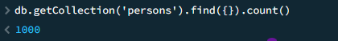

4) equality Query
Match by field name and its exact value
Syntax:
{<fieldname1>:<value1>, <fieldname2>:<value2>,…}
Example:
{“name”: “kity snow”}
{“age”: 32}
{“gender” : “female ”, “eyecolor” : “blue”}
- , between key value or field value pairs is AND condition (logical AND operator)
- “ …” in field names can be omitted not , without double commas field name can be written

example
db.getCollection(‘persons’).find({age: 24})
- this returns age: 24 matched from document ,all documents having age: 24 will be return
- 39 field and values are return from the document with the age: 24 in the query
Using AND condition
db.getCollection('persons').find({ gender: 'female',
eyeColor: 'green'})
- here it returns the documents from collection who’s field and value matches inside find method , AND means both field and values must be true
db.getCollection('persons').find({ gender: 'female',
eyeColor: 'green'}).count()
- returns how many documents match the query
Introduction to operators
- Operator adds condition to the query
  - Syntax
  - {<field Name1> : {<operator1>:<value1>},…}
- Operators like:
  - $ne -> not equals
  - $gt -> greater than so on….
1) comparision operators
1) $ne = not equal
2) $eq= equal
3) $lt= less than
4) $gt= greater than
5) $gte= greater than or equals to
6) $lte= less than or equals to
Example
Using comparison operator with strings
db.getCollection('persons').find({"eyeColor":{"$ne": "green"} })
- returns documents that fields are not equal to value green from collection
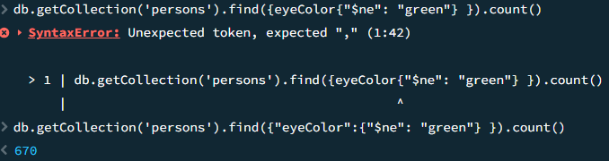
db.getCollection('persons').find({"age":{"$gt": 24, "$lt":36} }).count()
- sorting using operators and AND conditions
db.getCollection('persons').find({"name": {"$gt":"N"}}).sort({"name" : 1})
- sorts the name field from documents in ascending order using sort()

- we can compare dates as well
db.getCollection('persons').find({"registered" : {"$gt" : ISODate("2017-09-19T11:25:18.000Z")}}).count()
  - this returns number of matched pairs greater than the value given

LOGICAL OPERATOR’S
- $in and $nin operators
  - This operators require an array of value
- Example :

- {“eyeColor” : {“$in”: [“green”,”blue”]}}
- {“favouriteFruit” : {“$nin”: [“banana”,”apple”]}}

- db.getCollection('persons').find({"age" : {"$in":[22,21]} })
  - returns documents of having field age with value 21 or 22
- db.getCollection('persons').find({"age" : {"$in":[22,21]} })
  - returns documents of not having field age with value 21 or 22

- $and operator
  - Logically combines multiple conditions
  - Resulting documents must match ALL condition’s
  - Array of conditions separated from comma , $and operators require an array
  - Example
{ $and : [ {“gender”: ”male”} , {“age”: 25} ] }
{$and : [
{“age”: {“$ne”:25} },
{“age”: {“$gte”:20} } ] }

  - Using explicit $and with same field
{$ and : [ {“age”: {“$ne”:25} }, {“age”:{“$gte”:20} } ] }
Not equals to !=
{“age”: {“$ne”:25} }, {“age”:{“$gte”:20} } (without $and implicit)

  - Example through practice:
db.getCollection('persons').find({$and:[{"gender":"female"},{"age":24}]})
    - This returns documents with field gender of female and age of 24
  - db.getCollection('persons').find({"gender":"female"},{"age":24})
      - Returns the same explicit $and

  - db.getCollection('persons').find({$and:[{"age":{$gt:24}},{"age":{$lt:36}}]})
      - Returns the documents on given conditions
    - db.getCollection('persons').find({$and:[{"age":{$gt:24}},{"age":{$lt:36}}]}).sort({"age": 1})
      - return the given condition in ascending order

- db.getCollection('persons').find({age:{$ne: 25},age:{$gte: 25}})
- this condition does not work age:{$ne: 25} this is not satisfied

- db.getCollection('persons').find({age:{$gte: 25},age:{$ne: 25}})
  - in this case age:{$gte: 25} does not work
  - in this case with same name field age implicit $and operator is not used it can only work with explicit $and

- $or operator
  - Logically combines multiple conditions
  - Resulting documents must match ANY condition’s
  - Array of conditions separated from comma , $or operators require an array
  - Example
  - { $or : [ {“gender”: ”male”} , {“age”: 25} ] }

  - (the following is same as $in operator)
{$or : [
{“age”: 25 },
{“age”: 20} ] }
- To use $or operator with same field name use $in operator
- Just like the example given below
{$or : [
{“age”: 25 },
{“age”: 20} ] }

- Example shown through practice
- db.getCollection('persons').find({$or:[{isActive: true},{eyeColor: "blue"}]})
  - this returns document with either one condition satisfied , either isActive field with its value or eyeColor field with its value
- db.getCollection('persons').find({$or:[{eyeColor: "green"},{eyeColor: "blue"}]})
  - this return documents with either eyeColor green or eyeColor blue
- db.getCollection('persons').find({eyeColor: {$in:["green" , "boy"]}})
  - instead of using $or with same field name using $in is correct approach
  - returning documents are more proper in this

- QUERY EMBEDDED/NESTED DOCUMENTS
  - A document within a document ,along with another document
  - In simple words nesting documents within documents
  - Example
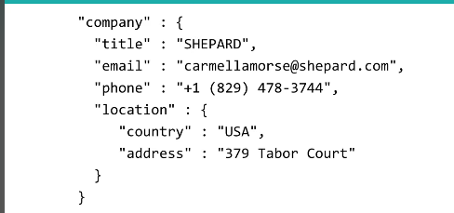
- to access a nested document we use .(dot) notation
- use dot notation with quotations
{“company.title”: “SHEPARD”}
{“company.location.address: “379 Tabor Court ”}
- Address is the property of location , location is the property of company
- Order of fields matter changing the order of field in the nested documents results zero fetched document

- Ordered nested document
db.getCollection('persons').find({"company" : {
title: 'GEOFORMA',
email: 'bentleysantana@geoforma.com',
phone: '+1 (868) 515-2120',
location: {
country: 'Germany',
address: '858 Royce Street'}
}})
- This returns the document with the following nested document
- Changed order nested document

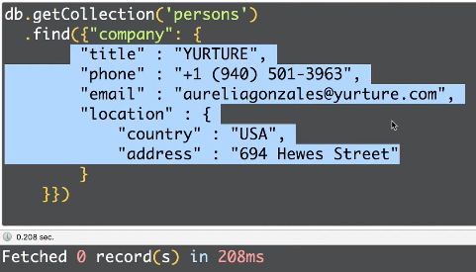

- Using dot notation (.)
  - db.getCollection('persons').find({"company.location.country" : "USA"})

returns the document with has country as USA
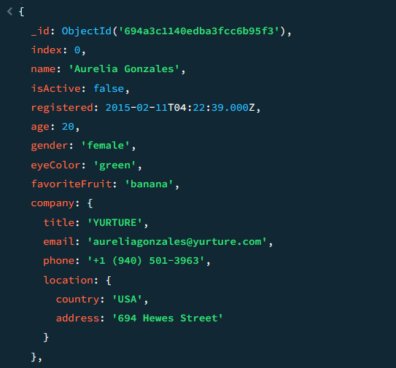

- db.getCollection('persons').find({"company.location.country" : "USA",
"company.title" : "EVENTAGE" }
)
Returns the document with country USA and title EVENTAGE

- Array and its operators
- query array by field value
  - array conatins certain value , looking the key pair below
{<feildname1>: <value1>}
  - specific element in array has certain value
{“<feildname1>.<index>”: <value1>}
  - this certain values of a specific element is accessed by dot notation with its <index> , index starting with zero
  - as dot notation use quotes
  - example
{ tags: “ad”}
{“tags.0” : “ad”}
{“tags.3”: “ab”}
- Consider this list of arrays called tags
  - tags: [
'eiusmod',
'dolore',
'et',
'id',
'incididunt'
]
}
1) db.getCollection('persons').find({tags: ['eiusmod', 'dolore','et','id', 'incididunt']})
this returns the document having the tags in them
2) db.getCollection('persons').find({tags: "et"})
this return the document with field tags having value as “et”
3) db.getCollection('persons').find({"tags.0": "et"})
returns document with tag field having value et at 0 index
  - query Array using $all ,$size

    - $all operator
    - It is independent of order
    - db.getCollection('persons').find({tags: {$all: ["et","esse"]}})
      - returns document with the given elements
    - db.getCollection('persons').find({tags: {$all: ["et",'exercitation']}})
      - returns the documents having following elements
    - $size operator
    - db.getCollection('persons').find({tags: {$size: 4}})
      - return document with field tags having 4 as size of values/elements

  - query Array of nested documents
{
_id: ObjectId('694ba51b0ce9a8706362bcdb'),
name: 'mike',
friends: [
{
name: 'bob',
age: 27,
registered: true
},
{
name: 'Alex',
age: 29,
registered: false
},
{
name: 'Jhon',
age: 23,
registered: true
}
]
}

- db.getCollection('first').find({"friends.name" : "Alex"})
  - returns the document with the array friend of sub document name with value Alex
- db.getCollection('first').find({"friends.age" : 23})
  - returns the document with the array friend with property/sub document of age with value 23
  - entire document is printed even asked for specific value

- db.getCollection('first').find({"friends.age" : {$lte: 23,$gt: 28}})
- returns the document with condition applied
db.getCollection('first').find({friends:{name: 'bob',
age: 27,
registered: true}})
  - this return the document with the sub document matched
db.getCollection('first').find({friends:{registered: true,name: 'bob',
age: 27,
}})
  - changing order of the sub document return zero result
db.getCollection('first').find({"friends.name": "Jhon","friends.age":23})
  - returns the matched document based on conditions
  - conditions over here don’t depend on each other, each one is checked separately and returns the document, below query shows more clear approach
db.getCollection('first').find({"friends.name": "Jhon","friends.age":27,"friends.registered" : false})
  - each condition is taken from three different sub documents returns the result of 3 of them, conditions don’t focus on any one sub documents to match and return the result

- $elemMatch operator
  - Very useful in querying arrays
db.getCollection('first').find({friends: {$elemMatch:{"name" : "Alex","age" :29}}})
  - Returns the document with sub document matched
  - Here each field name and age focuses on one document
  - Alex and 29 targets the single sub document
  - If different values given from different sub documents return nothing no match found
- db.getCollection('first').find({friends: {$elemMatch:{ ","age" :29,"name" : "Alex}}})
  - return the result even if order is changed

- element operator $exists $type
  - the $type it returns the type (data type) of the element
  - the $exists returns if a element exist in document
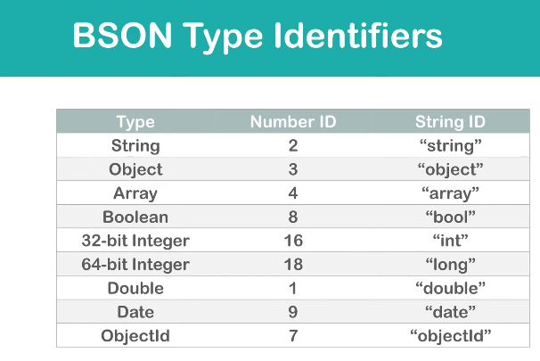
- db.getCollection('persons').find({"name": {$exists:true}}).count()
  - returns the document with field name , because in collection all documents have name as field
db.getCollection('persons').find({"index": {$type:"int"}}).count()
- returns 1000 as all documents have index field with int as its data type

- field filter
db.getCollection('persons').find({},{name:1,age:1,eyeColor:1})
    - filters the result with few fields
db.getCollection('persons').find({},{name:1,age:1,eyeColor:1,company:1})
    - return document with company as company has nested documents
db.getCollection('persons').find({},{name:1,age:1,eyeColor:1,"company.location.country" :1})
    - return the doc with location.country a nested doc within company
db.getCollection('persons').find({},{name:1,age:1,eyeColor:1,"company.location" :1})
    - returns the doc with location as location is nested with company ,location already has a nested doc containing address and country

db.getCollection('persons').find({},{name:0,age: 0})
returns doc with all fields except name and age
db.getCollection('persons').findOne({},{name:1,age: 1})
returns only one doc by using findOne()
$regex operator
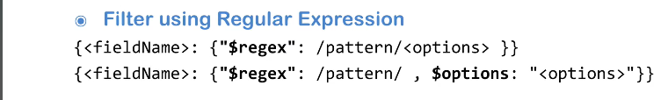
Operators used is $regex operators and $options (if options are placed separately)
db.getCollection('persons').find({name:{$regex:/rel/i}})
    - here field name is “name” using $regex operator giving pattern “/rel/” with options “i” as “i” is incase sensitive
db.getCollection('persons').find({name:{$regex:/Aur/, $options: "i"}})

-> in this query separate $options is used when using this operator $options: "i", i should be within quotation
$options: "i” if not using this it by default considers case sensitive , following query explains well
    - db.getCollection('persons').find({name:{$regex:/Aur/}})
- db.getCollection('persons').find({name:{$regex:/^Aur/}})
    - {$regex:/^Aur/} in this query “^” means starting returns doc with starting of Aur pattern
- db.getCollection('persons').find({name:{$regex:"Aur"}})
    - this also results the same

- aggregate command
  - performs aggregation operation using aggregation pipeline
  - aggregation pipeline allows users to process data from a collection with a staged –based manipulations
  - Syntax
db.runCommand(
{
aggregate: "<collection>" || 1,
pipeline: [ <stage>, <...> ],
explain: <boolean>,
allowDiskUse: <boolean>,
cursor: <document>,
maxTimeMS: <int>,
bypassDocumentValidation: <boolean>,
readConcern: <document>,
collation: <document>,
hint: <string or document>,
comment: <any>,
writeConcern: <document>,
let: <document> // Added in MongoDB 5.0
}
)
  - Required and must have fields are
    - Aggregate (string)
      - includes the name of collection that act as an input
    - Cursor (document)
    - You must use the aggregate command with the cursor option unless the command includes the explain option.
      - To indicate a cursor with the default batch size, specify cursor: {}.
      - To indicate a cursor with a non-default batch size, use cursor: { batchSize: <num> }.
    - Pipline (array)
      - Array of aggregation pipeline stages that transform and process the document as a part of aggregation pipeline

More simpler syntax
db.<collection>.aggregate([
<stage 1>,
<stage 2>,
…
<stage N>
])
  - Using db.persons.aggregate([]) returns same as find method
  - Changes occure when we use stages in aggregate

- Aggregate pipeline
  - Aggregation pipeline consist of one or more stages that process documents
  - Documents can be from collection , views
  - Each stages perform an operation on the input documents
  - Example a stage can perform
    - $filter documents
    - $group documents
    - The output is then passed to next stage in pipeline
  - Aggregation pipeline returns result of groups of documents
  - Documents can be updated within aggregation pipeline using stages

- Updates within Aggregation Pipeline
  - To perform update operations using aggregation pipeline it consist following stages
  - $addFields

  - $set

  - $project

  - $unset

  - $replaceRoot

  - $replaceWith

Aggregation stage operators
Each stage starts with $stage operator
Example
$match ( a aggregation stage operator )
$group
$ sort
$ project
$limit
$skip so on……
Aggregation expressions
Expression have two parts :
Left side is the aggregate stage operator
Right side is the reference of field name as input documents
With quotations otherwise its consider a variable
Example
{$group :{ __id : “$age”}}

$match stage operator
db.persons.aggregate([
// stage 1
{$match :{isActive: true}}])

    - Returns doc with isActive: true
db.persons.aggregate([
// stage 1
{$match :{tags : {$size :3}}}])

    - Returns the doc with tag array having 3 elements in its array

The following operations if performed by find query results the same or equals to the aggregate query only with stage 1

$group stage operator
In each group stage __id is mandatory
db.persons.aggregate([
// stage 1
{$group : { _id: "$age"}}])

    - Returns the doc from collection by grouping the doc by age field name
    - Results are not sorted returned by $group
db.persons.aggregate([
// stage 1
{$group : { _id: "$gender"}}])

// output
- {
- _id: 'male'

_id: 'female'
-> this query returns the group based on gender , so collection has two groups male and female

$ group by nested documents
db.persons.aggregate([
// stage 1
{$group : { _id: "$company.location.country"}}])

// output
{
_id: 'France'
}
{
_id: 'USA'
}
{
_id: 'Germany'
}

$ group by multiple fields
db.persons.aggregate([
// stage 1
{$group : { _id:{age : "$age" , gender:"$gender"}}}])

// output
{
_id: {
age: 28,
gender: 'female'
}
Using $group and $match together
db.persons.aggregate([
//stage 1
{$match : {favoriteFruit : "banana"}},
// stage 2
{ $group :{_id: {age:"$age",eyeColor:"$eyeColor"}}}])

//output
{
_id: {
age: 33,
eyeColor: 'brown'
}
the stage 1 $match is first performed so matches the document with favorite fruit banana
then goes to stage 2 $group the result is documented into groups of age and eyeColor based on stage 1
To check that the stage 2 are resulted by stage 1 like matched with favorite fruit banana
Following query confirms and result as well
db.persons.aggregate([
//stage 1
{$match : {favoriteFruit : "banana"}},
// stage 2
{ $group :{_id: {age:"$age",eyeColor:"$eyeColor",fruit:"$favoriteFruit"}}}])
// output
{
_id: {
age: 25,
eyeColor: 'green',
fruit: 'banana'
}

Swapping $match and $group
db.persons.aggregate([
// stage 2
{ $group :{_id: {age:"$age",eyeColor:"$eyeColor",fruit:"$favoriteFruit"}}},
//stage 1
{$match : {favoriteFruit : "banana"}}

])
// output is empty because order has changed
Another approach to solve the swapping is done by below query
db.persons.aggregate([
// stage 2
{ $group :{_id: {age:"$age",eyeColor:"$eyeColor"}}},
//stage 1
{$match : {'_id.eyeColor' : 'blue'}}

])

// output
{
_id: {
age: 25,
eyeColor: 'blue'
}
$ count
db.persons.aggregate([
{$count : "allDocumentsCount"}
])

{
allDocumentsCount: 1000
}
db.persons.aggregate([{$count : "total"}])

// output
{
total: 1000
}
db.getCollection('persons').find({}).count()

// returns the same output as aggregate method
// find count () is the wrapper of the Aggregate $count

Using $ group $ count and $ match
db.persons.aggregate([
// stage 1
{$match :{age: {$gt:20}}},
// stage 2
{$group: {_id:{age:"$age"} }},
// stage 3
{$count: 'age'}
])
returns number of groups of gt 20
$ sort
Sort the documents by certain fields , -1 is for descending and 1 ascending
db.persons.aggregate([{
$sort:{name:1}
}])

    - The document will be sorted with name field in alphabetical order
db.persons.aggregate([{
$sort:{name:-1}
}])

    - Reverse the alphabet order

Using $ sort and $ group
db.persons.aggregate([{
$group: {_id: "$favoriteFruit"}},
{$sort: {_id: 1}}])

// output
{
_id: 'apple'
}

_id: 'banana'
}
{
_id: 'strawberry'
}
$ project stage
Excluding including the fields
db.persons.aggregate([{
$project: { name: 1, "company.location.country": 1}}])

// returns a large document into a required order of documents
It returns name , company with location with country in ascending order , only the fields mentioned in the input
Restructuring the fields with $ project
db.persons.aggregate([{
$project: { _id: 0, name: 1,
info:{
eyecolor: "$eyeColor",
favfruit: "$favoriteFruit",
country: "$company.location.country"} }}])

// output
{
name: 'Aurelia Gonzales',
info: {
eyecolor: 'green',
favfruit: 'banana',
country: 'USA'
}
}

CRUD operations in MongoDB
1) insert
db.first.insertMany([{name: "user 1",age:22, role:"student"},
{name: "user 2",age:21, role:"clerk"},
{name: "user 3",age:27, role:"coordinator"}])
2) to view data
db.first.find()
3) updating documents
Updating one document
db.first.updateOne({name: "user 1"},{$set:{age:45}})

here name: "user 1" is the condition, where user 1 is name in the document update its age with the second condition {$set:{age:45}
prev age was 22 updated is 45 done $set operator
// output
{
acknowledged: true,
insertedId: null,
matchedCount: 1,
modifiedCount: 1,
upsertedCount: 0
}
Updating many
Same using $ set but the condition should match multiple documents like condition should be similar in more than one documents
4) deleting
db.first.deleteOne({name:'user 1'})

// field with name value user 1 is deleted
deleteMany
needs to have a similar query like age , country, city

- Crud operations through Pymongo
- Anaconda setup
1) checking version
2)initializing conda
3) creating environments
4) activating and deactivating environments
5) listing env
6) removing existing env
7) conda vs pip
8) installing packages
9) updating packages
10) removing packages
11) searching for packages
12) use of environments

